<Arithmetic Evaluator>

User’s Manual

Version <1.0>

Revision History

|  |  |  |  |
| --- | --- | --- | --- |
| **Date** | **Version** | **Description** | **Author** |
| <29/11/23> | <1.0> | <First additions to user manual> | <Xavier Ruyle> |
|  |  |  |  |
|  |  |  |  |
|  |  |  |  |

Table of Contents

1. Purpose 4

2. Introduction 4

3. Getting started 5

4. Advanced features 5

5. Troubleshooting 6

6. Example of uses 6

7. Glossary 6

8. FAQ 6

User Manual

# Purpose

The purpose of this document is to inform the user of how to install and use the MXDC calculator. It will outline the problems that a user might face installing or running the program and answer commonly asked questions about the calculator. It will also provide the user with examples of the calculator’s usage.

# Introduction

This software includes an arithmetic expression calculator which allows the user to calculate expressions over the command line.

To download the software the user should:

1. clone the repository.



1. Open a command line and locate the repository’s directory.
2. Open the calculator/bin director using either file explorer or command line

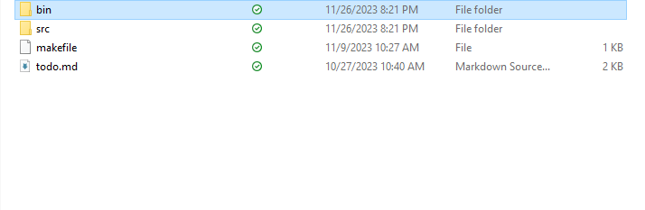

1. run the calculator.exe file by typing ./calculator.exe or by double clicking the executable using file explorer

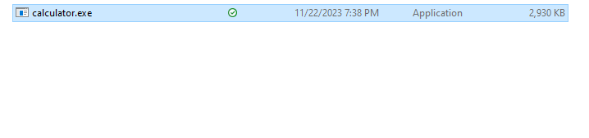

1. You should now be able to input expressions into the command line

# Getting started

After starting the calculator.exe program, the user should see a prompt that looks like this.

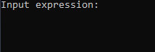

As you might expect, the user can type any valid expression here and obtain a result.



A prompt will then show up which asks the user if they would like to continue



If the user types y, they can input another expression, otherwise, the program will exit.

The user can use any valid operator from the following list, [(, ), -, +, /, *, ** or ^, % ], however sin, cos or other functions are not available.

Floating point calculatings are also a feature.

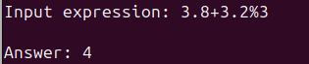

If a user encounters an error, the prompt will display an error that looks like this.

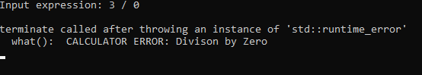

The program will then exit.

# Advanced features

Since this is a simple arithmetic expression calculator, there are no custom functions or variables for this calculator and there is no ability to save and load expressions.

# Troubleshooting

Running calculator.exe by double clicking in a file explorer does not work.

* try to run it in the command line as directed in the introduction.

# Examples

A good starting point is a basic addition calculation.





Exponents can be represented by either ** or ^.



Expressions follow PEMDAS rules.



Whitespace is ignored for user input.



# Glossary of terms

Clone: to use the git clone command

Repository: Another git term. The repository from the GitHub page

PEMDAS: Order of operations

# FAQ

Are functions a feature?

* No, functions are not a feature since they are not in the scope of the project deliverables.

Are variables a feature?

* No, algebra is not within the scope of the project deliverables.

Does whitespace matter for user input?

* No, the tokenizer will ignore whitespace

Can I use x for multiplication, or ÷ for division?

* No, the user must use correct ascii values for operators. However, exponents can be used by either inputting ** or ^.